REAGEN™

Monensin ELISA Test Kit
RND99056

Product Description

REAGEN™ Monensin ELISA Test Kit enables government agencies, food manufacturers and quality assurance organizations to detect monensin in feed to satisfy customer concerns about food safety. The Monensin ELISA Test Kit provides a unique extraction method, which is accurate, rapid, cost effective and easy to use. The features of the kit are:
- The extraction of monensin from samples can be finished in 45 -60 minutes with a high recovery rate of 75 - 115%
- High reproducibility
- A quick ELISA assay (less than 1.5 hours regardless of number of samples)

Procedure Overview

The method is based on a competitive colorimetric ELISA assay. The monensin antibody has been coated in the plate wells. During the analysis, sample is added along with the monensin-horseradish peroxidase conjugate. If monensin residue is present in the sample, it will compete for the monensin antibody, thereby preventing the monensin-HRP from binding to the antibody attached to the well. The resulting color intensity, after addition of the HRP substrate (TMB), has an inverse relationship with the monensin residue concentration in the sample.

Kit Contents, Storage and Shelf Life

REAGEN™ Monensin ELISA Test Kit has the Cyproheptadineacity for 96 determinations or testing of 42 samples in duplicate (assuming 12 wells for standards). Return any unused microwells to the foil bag and reseal them with the desiccant provided in the original package. Store the kit at 2-8C *. The shelf life is 12 months when the kit is properly stored.
Kit Contents | Amount | Storage
Monensin Ab -coated Plate | 1 x 96-well plate (8 wells x 12 strips) | 2-8°C
Monensin Standard Stock 300 ppb | 1.0 mL | 2-8°C
4x Monensin Sample Buffer | 30 mL | 2-8°C
Monensin-HRP Conjugate | 12 mL | 2-8°C
Monensin Clean up Mix | 26 g | 2-8°C
20X Wash Solution ** | 30mL | 2-8°C
Stop Buffer ** | 14 mL | 2-8°C
TMB Substrate ** | 10 mL | 2-8°C

* If you are not planning to use the kit for over 1 month, store Monensin-HRP Conjugate at -20°C or in a freezer.

Sensitivity

Sample Type | Detection Limit (ng/g or ppb)
Feed/Meat | 30

Specificity

Analytes | Cross-Reactivity (%)
Monensin | 100

Required Materials Not Provided With the Kit

- Microtiter plate reader (450 nm)
- Incubator
- Tissue Mixer (e.g. Omni Tissue Master Homogenizer)
- Vortex mixer (e.g. Genie Vortex mixer from VWR)
- 10, 20, 100 and 1000 μL pipettes
- Methanol
- Analytical balance
- Multi-channel pipette: 50-300 μL (Optional)

Warnings and Precautions

- The standards contain Monensin. Handle with particular care.
- Do not use the kit past the expiration date.
- Do not intermix reagents from different kits or lots except for components with the same part No’s within their expiration dates.
- Try to maintain a laboratory temperature of 20°–25°C (68°–77°F). Avoid running assays under or near air vents, as this may cause excessive cooling, heating and/or evaporation. Also, do not run assays in direct sunlight, as this may cause excessive heat and evaporation. Cold bench tops should be avoided by placing several layers of paper towel or some other insulation material under the assay plates during incubation.
- Make sure you are using only distilled or deionized water since water quality is very important.
- When pipetting samples or reagents into an empty microtiter plate, place the pipette tips in the lower corner of the well, making contact with the plastic.
- Incubations of assay plates should be timed as precisely as possible. Be consistent when adding standards to the assay plate. Add your standards first and then your samples.
- Add standards to plate only in the order from low concentration to high concentration as this will minimize the risk of compromising the standard curve.
- Always refrigerate plates in sealed bags with a desiccant to maintain stability. Prevent condensation from forming on plates by allowing them equilibrate to room temperature (20 – 25°C / 68 – 77°F) while in the packaging.

SAMPLE PREPARATION

Be sure samples are properly stored. In general, samples should be refrigerated at 2-4°C for no more than 1-2 days. Freeze samples to a minimum of -20°C if they need to be stored for a longer period. Frozen samples can be thawed at room temps (20 – 25°C / 68 – 77°F) or in a refrigerator before use.

Preparation of 1x Monensin Sample Buffer:

Mix 1 volume of the 4x Monensin Sample Buffer with 3 volumes of distilled water.

Feed & Chicken Meat

Homogenize the sample with a suitable mixer.

Take 0.5 g of the homogenized sample and place into 15 mL tube

Add 7.5 mL of methanol, vortex vigorously for 15 minutes in a multi-tube vortexer or shaker, or vortex for 3 minutes at maximum speed manually.

Centrifuge the sample for 10 minutes at 4,000 X g at room temperature (20-25 °C/68-77°F).

Take 1.0 mL of supernatant to a new 2 mL tube and add 250 mg of Monensin Clean Up Mix.

Vortex vigorously for 0.5 minute and leave at room temperature for 5 minutes.

Centrifuge the sample for 2 minutes at 14,000 X g at room temperature (20-25 °C/68-77°F).

Take 50 μL of supernatant to a 2-mL tube Use an evaporator to dry the sample at 60°C , Alternatively, the sample can be dried by blowing nitrogen gas in a 60°C water bath or at room temperature for a longer time.

Add 1000 µL of Monensin Sample Buffer to the dried tube and vortex vigorously for 1 minute.

Use 100 μL of the extraction solution per well in the ELISA test.

Note: Dilution factor: 300. To obtain a lower detection limit, the dilution factor can be changed to 30 by transferring 500 µL, instead of 50 µL, of the supernatant in Step 8. In contrast, if a higher detection limit is needed, the dilution factor can be changed to 3000 by transferring 5 µL, instead of 50 µL, of the supernatant in Step 8.

MONENSINELISA TEST KIT PROTOCOL

Reagent Preparation

IMPORTANT: All reagents should be brought up to room temperature before use (1 – 2 hours at 20 – 25°C / 68 – 77°F); Make sure you read “Warnings and Precautions” section on page 3. Solutions should be prepared just prior to ELISA test. All reagents should be mixed by gently inverting or swirling prior to use. Prepare volumes that are needed for the number of wells being run. Do not return the reagents to the original stock tubes/bottles. Using disposable reservoirs when handling reagents can minimize the risk of contamination and is recommended.

- Preparation of 1X Wash Solution
Mix 1 volume of the 20X Wash Solution with 19 volumes of distilled water.

- Preparation of Monensin Standards
The Monensin standard stock concentration is 300 ppb. Prepare the following standards by serial dilution starting from the highest concentration to the lowest in 2 mL tubes; mix well each standard vial by vortexing for 30 seconds. Make standards fresh each time performing the assay.

Work Standards | Volume of Monensin Source | Volume of Sample Buffer
15 ppb | 100 µL from 300 ppb stock | 1900 µL
7.5 ppb | 1000 µL from 15 ppb vial | 1000 µL
5 ppb | 1000 µL from 7.5 ppb vial | 500 µL
2.5 ppb | 500 µL from 5 ppb vial | 500 µL
1 ppb | 400 µL from 2.5 ppb vial | 600 µL
0 ppb | 0 µL | 500 µL

ELISA Testing Protocol

Label the individual strips that will be used and aliquot reagents as the following example:

Component | Volume per Reaction | 24 Reactions
Monensin -HRP | 50μL | 1.2mL
1X Wash Solution | 0.75 mL | 18mL
Stop Buffer | 100 μL | 2.4 mL
TMB Substrate | 100 μL | 2.4 mL

- Add 100 μL of each Monensin Standard in duplicate into different wells. (Add standards to the plate in the order of low concentration to high concentration as follows: 0, 1, 2.5, 5, 7.5, 15 ppb)
- Add 100 μL of each sample in duplicate into different sample wells.
- Add 50 μL of Monensin-HRP and mix well by gently rocking the plate manually for 1 minute.
- Incubate the plate for 60 minutes at room temperature. (20 – 25°C / 68 – 77°F) (Covering the plate while incubating is recommended.)
- Wash the plate 3 times with 250 μL 1X Wash Solution. After the last wash, invert the plate and gently tap the plate dry on paper towels. (Perform the next step immediately after plate washings. Do not allow the plate to air dry between working steps.)
- Add 100 μL of TMB substrate. Time the reaction immediately after adding the substrate. Mix the solution by gently rocking the plate manually for 1 minute while incubating.
(Do not put any substrate back to the original container to avoid contamination. Any substrate solution exhibiting coloration is indicative of deterioration and should be discarded. Covering the plate while incubating is recommended.)
- After incubating for 15 minutes at room temperature (20 – 25°C / 68 – 77°F), add 100 μL of Stop Buffer to stop the enzyme reaction.
- Read the plate as soon as possible following the addition of Stop Buffer on a plate reader with 450 nm wavelength ( Before reading, clean the bottom of the plate with a lint-free wipe to ensure no moisture or fingerprints interfere with the readings).

Monensin Concentration Calculations

A standard curve can be constructed by plotting the mean relative absorbance (%) obtained from each reference standard against its concentration in ng/mL on a logarithmic curve.

Relative absorbance (%) =

The following figure is a typical Monensin standard curve

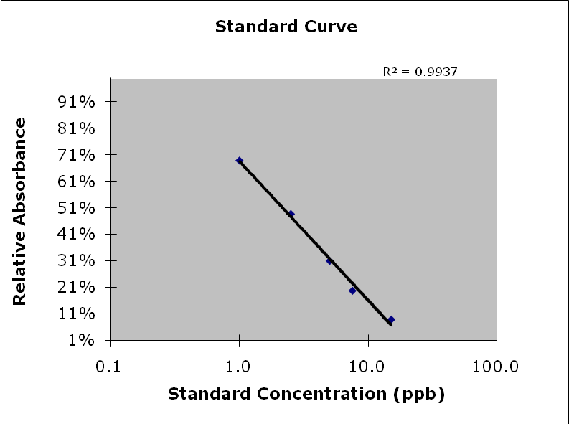

REAGEN LLC
Add.: 102CommerceDr.Unit8,Moorestown,NJ08057
Tel.:856-727-0250 FAX.:856-727-0251
E-mail:reagenkits@gmail.com reagenllc@gmail.com
Web.: www.reagen.us

