REAGEN™
β-Hydroxybutyrate Assay Kit
RNN89004

Product Description
REAGEN™ β-Hydroxybutyrate Assay Kit is a plate-based colorimetric enzymatic assay for the quantitative determination of β-Hydroxybutyrate in serum samples.The kit uses a spectrophotometric assay to detect β-Hydroxybutyrate directly from serum samples, enabling researchers to detect β-Hydroxybutyrate levels in animal serum and other tissue matrices such as urine and ascites. The unique features of the kit are:
- High sensitivity and wide linear range (0 - 4.5 mM).
- A rapid (5 minute) and robust enzyme-based assay which does not require expensive instrumentation.
- High reproducibility.

Procedure Overview
After preparing the sera, the assay is performed by adding β-Hydroxybutyrate Reagent A into microplate wells containing 6 µL sera. The absorbance of each well at 505 nm is measured by a plate reader. β-Hydroxybutyrate Reagent B is then added to each well. After a brief incubation at room temperature, the final absorbance of each well at 505 nm is measured again. The concentration of β-Hydroxybutyrate in each sample is then directly determined from the change of 505 nm absorbance.

Kit Contents, Storage and Shelf Life
REAGEN™ β-Hydroxybutyrate Assay Kit has the capacity for 96 determinations or testing of 42 samples in duplicate (using 12 wells for standards). Store the kit at 4°C. The shelf life is 6 months after receipt when the kit is properly stored.

Kit Contents | Amount | Storage
Microtiter Plate | 1 x 96-well plate (8 wells x 12 strips) | 4°C – 30°C
β-Hydroxybutyrate Standard | 1.5 mL | 4ºC
β-Hydroxybutyrate Reagent A | 25 mL | 4ºC
β-Hydroxybutyrate Reagent B | 4 mL | 4ºC

Required Materials Not Provided With the Kit
- Microtiter plate reader (505 nm)
- Centrifuge to prepare serum samples
- Deionized or distilled water
- 1.5 mL microfuge tubes
- Phosphate-buffered saline (PBS)
- Multichannel pipet or repeating pipettor (recommended but not required)

Warnings and Precautions
- Add standards to plate only in order from low concentration to high concentration, as this will minimize the risk of compromising the standard curve.
- Anticoagulants such as fluoride and oxalate will result in false low values.
- The assay is not influenced by hemoglobin values up to 200 mg/dl or by bilirubin levels up to 10 mg/dl.
- Interference from grossly hemolyzed specimens is correctable by use of a serum/plasma blank.

SAMPLE PREPARATION

- Carefully prepare at least 20 µL of sera using standard production procedure (if determinations are performed in singlet then 10 µL is sufficient). Avoid hemolysis, as it may give falsely high values.
- Serum or plasma β-Hydroxybutyrate is reported stable for 7 days when stored at 4°C and for 3 weeks if frozen.
Note: Samples with values above 4.5 mM should be diluted 1:1 with PBS and re-tested.
Multiply results by two.

β-HYDROXYBUTYRATE DETERMINATION TEST PROTOCOL
Setup
Allow reagent and standard come to room temperature (25°C) before use. Turn on the plate reader and allow the lamp to warm up. Adjust the wavelength of the plate reader to 505 nm.
Reagent Preparation
Reagent comes in a ready to use form. Reagents and standard are stable until the expiration date on the kit label when stored at 2 - 8°C.
Preparation of Total Protein Control Dilutions for Standard Curve

- Label 6 microfuge tubes: 1, 2, 3, 4, 5, 6.
- Dilute the β-Hydroxybutyrate Standard using Distilled Water as described in the table below. After dilution, briefly mix each tube.
Tube # | Volume  β-Hydroxybutyrate(1mM) | Volume Distilled Water | β-Hydroxybutyrate Concentration (mM)
1 | 0µL | 100µL | 0
2 | 20µL | 100µL | 0.167
3 | 40µL | 80µL | 0.333
4 | 50µL | 50µL | 0.5
5 | 80µL | 40µL | 0.667
6 | 100µL | 0µL | 1
- Use 6 µL of each diluted standard per reaction (see below)
Sample Test Procedure
- Add 6 µL of each sample or standard (in duplicate) to the microplate wells.
- Add 215 µL of β-Hydroxybutyrate reagent A to the wells.
- Measure the absorbance of each well at 505 nm (A0)
- Add 36 µL of β-Hydroxybutyrate reagent B to the wells. Incubate the reactions for 5 minutes at room temperature.
- Measure the absorbance of each well at 505 nm (Af).
- Subtract A0 from Af to obtain the absorbance change (= Af - A0) for both samples and standards.
β -Hydroxybutyrate Concentration

There is a linear relationship between the concentration of β-Hydroxybutyrate in the sample and absorbance change (= Af -A0) at 505 nm. Therefore, a standard curve used to calculate the β-Hydroxybutyrate concentration in serum samples can be constructed by plotting the mean corrected absorbance values for each of the diluted β-Hydroxybutyrate standards as a function of β-Hydroxybutyrate concentration. The standard curve provides a reference for the linear range of the assay. To obtain mg/dL, divide the value obtained in mM by 0.096.

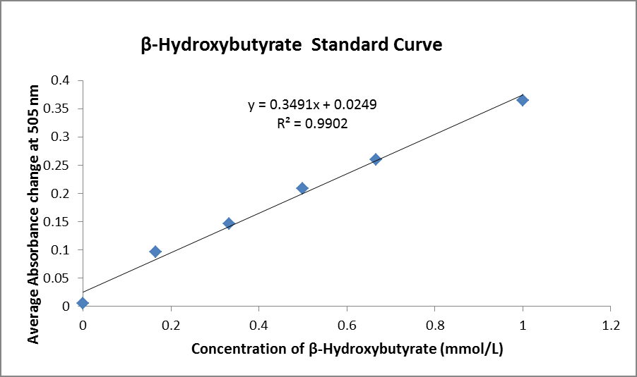
REAGEN LLC
Add.: 102CommerceDr.Unit8,Moorestown,NJ08057
Tel.:856-727-0251 FAX.:856-727-0250
E-mail:reagenkits@gmail.com reagenllc@gmail.com
Web.: www.reagen.us

