REAGEN™
L-Carnitine Colorimetric/Fluorometric Assay Kit
RNF91016

Product Description

REAGEN™ L-Carnitine Colorimetric/Fluorometric Assay Kit is a simple convenient means of measuring free L-Carnitine in biological samples such as milk powder/serum/Feed.
The unique features of the kit are:

- High sensitivity and low detection limit(The detection sensitivity is ~1 µM (fluorometric) and ~10 µM (colorimetric))
- High reproducibility
- A rapid robust enzyme-based assay.

Procedure Overview

Carnitine is a quaternary ammonium compound biosynthesized from lysine and methionine. It is required for fatty acid transport into the mitochondrial matrix via the carnitine/ acylcarnitine shuttle, where β-oxidation occurs, acetate is generated and the acetate utilized in the TCA cycle for the generation of energy. Carnitine exists in two stereoisomers. Only L-carnitine is biologically active.
REAGEN™ L-Carnitine Colorimetric/Fluorometric Assay Kit assay transfers an acetyl group from CoA to Carnitine and the free CoA formed is further processed with subsequent oxidation of the Oxi-Red probe to give fluorescence (Ex/Em535/587 nm) and absorbance (570 nm).

Kit Contents, Storage and Shelf Life

Kit Contents | Amount | Cap Code
Carnitine Assay Buffer | 25 mL | WM
Carnitine Probe (in DMSO) | 0.2 mL | Red
Carnitine Converting Enzyme | lyophilized | Purple
Carnitine Substrate Mix | 400 µl | Blue
Carnitine Development Mix | lyophilized | Green
Carnitine Standard (10 µmol) | lyophilized | Yellow

REAGEN™ L-Carnitine Colorimetric/Fluorometric Assay Kit Store the kit at -20°C, protect from light. Allow Assay Buffer to warm to room temperature before use. Briefly centrifuge vials prior to opening. Read the entire protocol before performing the assay.

REAGENT RECONSTITUTION AND GENERAL CONSIDERATION

Carnitine Probe: Ready to use as supplied. Warm to room temperature to melt frozen DMSO before use. Protect from light and moisture. Stable for 2 months at -20°C.
Carnitine Converting Enzyme, Development Mix: Dissolve with 220 µl Carnitine Assay Buffer separately. Pipette up and down to dissolve. Aliquot and store at –20°C. Avoid repeated freeze/thaw cycles. Use within two months.
Carnitine Substrate Mix: Ready to use as supplied. Bring to room temperature to melt frozen DMSO. Will show cloudiness which does not interfere with the assay.
Carnitine Standard: Dissolve in 100 µl dH2O to generate 100 mM (100 nmol/µl) Carnitine Standard solution. Keep on ice while in use. Store at -20°C.
Keep the Enzyme and Development Mix on ice during the assay and protect from light. Ensure that the Assay Buffer is warmed to room temperature before use.

CARNITINE ASSAY PROTOCOL

1. Carnitine Standard Curve:
For the Colorimetric Assay: Dilute 10 µl of the 100 mM Carnitine Standard with 990 µl dH2O to generate 1 mM standard Carnitine. Add 0, 2, 4, 6, 8, 10 µl of the diluted Carnitine Standard into a 96-well plate to generate 0, 2, 4, 6, 8, 10 nmol/well standard. Bring the volume to 50 µl with Assay Buffer.
For the Fluorometric Assay: Dilute the standard to 0.1 mM (0.1 nmol/µl), then follow the same protocol as colorimetric assay. Will give 0, 0.2, 0.4, 0.6, 0.8, 1 nmol/well.

2. Sample Preparation:
Tissues or cells (1×106) can be homogenized in 100 µl Assay Buffer and centrifuged to remove insoluble materials at 13,000 g for 10 min. 10-50 µl deproteinized serum samples can be directly diluted in the Assay Buffer. Bring sample wells to 50 µl/well with Assay Buffer in a 96-well plate. We suggest testing several doses of your sample to make sure the readings are within the standard curve range. Deproteinization may be done by PCA precipitation followed by KOH neutralization (BioVision K808-200) or using centrifugation through a 10kDa MW cut-off filter (BioVision part 1997-25). The normal range for serum L- carnitine is ~ 10-70 µM.
3.Reaction Mix:
Mix enough reagent for the number of assays to be performed. For each well, prepare a total 50 µl Reaction Mix containing:

 | L-Carnitine Measurement | Background Control*
Assay Buffer | 40 µl | 42 µl
Carnitine Converting Enzyme | 2 µl | ------
Carnitine Development Mix | 2 µl | 2 µl
Carnitine Substrate Mix | 4 µl | 4 µl
Carnitine Probe** | 2 µl | 2 µl
* Perform background control if high levels of acyl -CoA’s or free Coenzyme A are suspected to be in your samples. Choline in samples will give a positive signal but is present at ~10% of the Carnitine concentration.
** For the fluorescent assay, dilute the probe 10X to reduce background reading.
Add 50 µl of the Reaction Mix to each well containing the Carnitine standard, test and background control samples. Mix well. Incubate the reaction for 30 min at room temperature, protect from light.
4. absorbance values:
Measure OD at 570 nm, or fluorescence at Ex/Em 535/587 nm in a microplate reader.
5. Calculation:
Correct background by subtracting the value derived from the 0 Carnitine control from all sample and standard readings (The background reading can be significant and must be subtracted from sample readings). Plot Carnitine standard curve. Apply sample readings to the standard curve. Carnitine concentrations of the test samples can then be calculated:
C = Sa/Sv (nmol/µl, or mM)
where Sa is the Carnitine content of unknown samples (in nmol) from standard curve, Sv is sample volume µl) added into the assay wells.
L-Carnitine Molecular Weight is 161.2 g/mol.
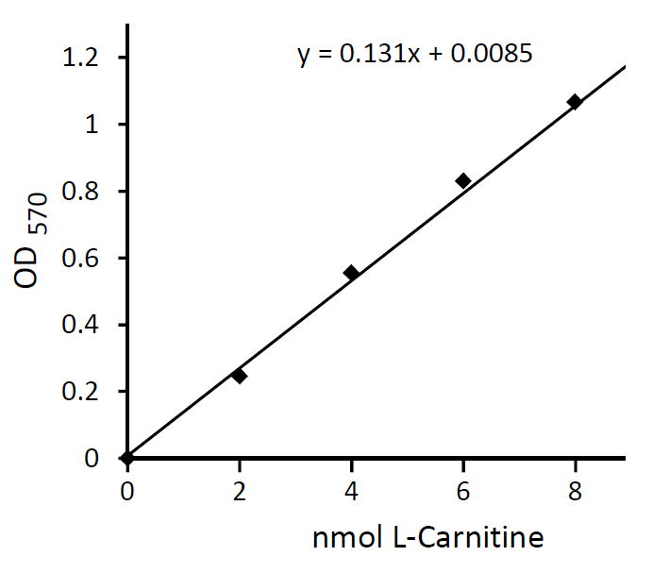

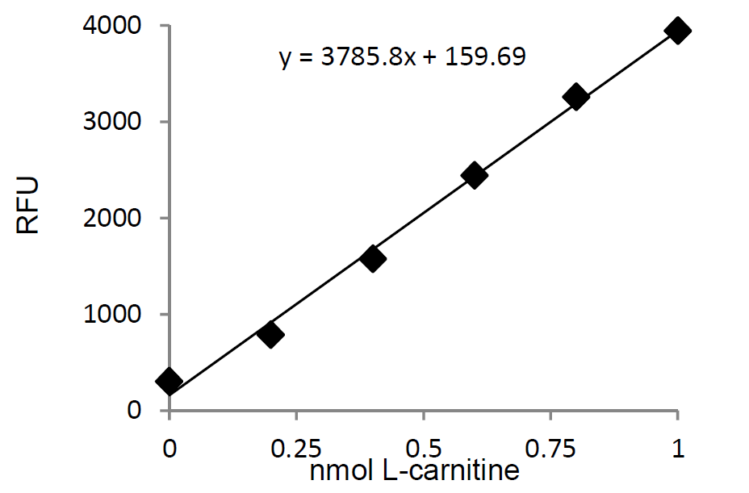

REAGEN LLC
Add.: 102CommerceDr.Unit8,Moorestown,NJ08057
Tel.:856-727-0250 FAX.:856-727-0251
E-mail:reagenkits@gmail.com reagenllc@gmail.com
Web.: www.reagen.us

